i

A study of interdependence of birds, butterflies and insects on the forest trees and shrubs in Forests around Bangalore and exploring the possibility of selecting candidate species for urban forestry to enhance urban biodiversity

Submitted by:

N.K. Arun
&
S. Prashanth

PROJECT GUIDES
Dr Subramanya. S – Ornithology and Entomology
Sheshadri.R – Forest Trees and Shrubs

Submitted to:
Ashoka Trust for Research in Ecology and the Environment (ATREE)
Royal Enclaves, Srirampura, Jakkur post
Bangalore, India - 560064
July 2011

CONTENTS

CHAPTER | PARTICULARS | PAGE NO
i | List of Tables
ii | List of Figures
1 | INTRODUCTION & OBJECTIVES
2 | LIST OF PLATES
3 | MATERIALS AND METHODS
4 | RESULTS AND DISCUSSION
5 | REFERENCES
6 | ACKNOWLEDGEMENTS

LIST OF TABLES

SL.NO | PARTICULARS | PAGE NO
1 | Trees for Highway planting – National & State
2 | Trees for planting on narrow roads
3 | Trees for planting on wide roads
4 | Trees for planting in Gardens and public parks
5 | Trees for woodlots
6 | Heritage, long living and trees for gunduthopus
7 | Trees for general public
8 | Bee flora for Gardens and woodlots
9 | Trees with hollows for cavity nesting birds
10 | List of trees lost during heavy rains and monsoons
11 | Trees that have never been planted in cities

LIST OF PLATES

SL.NO | PARTICULARS | PAGE NO
1

Introduction & Objectives

Forests are living communities in which no single species whether floral or faunal, can be viewed in isolation. Each entity is linked to the other, either directly or indirectly, in a complex web.

The relationship between birds, butterflies, honey bees and other insects with trees and shrubs is one of very close interdependence. Natural forests, with their multi-tiered vegetation, have always been the ideal home for a large variety of birds, insects and other fauna. The many different forest types in India’s varied geo-climatic zones have provided ecological niches for forest-dwelling avifauna for feeding, roosting, nesting and cover. Birds, butterflies, honey bees and other insects in turn perform the multiple services of pollination, seed dispersal, biological control and soil enrichment, all of which, are essential for the health of an ecosystem. Perhaps, two of the important roles of forest birds are pollination and seed (fruit) dispersal of forest tree species. Insects too play their role in the propagation of trees and plants by pollination. An effective forest regeneration would involve understanding the inter dependence between flora and fauna.

According to a recent study made by Harini Nagendra and Divya Gopal, in a place like Bangalore, an overwhelming majority (Almost 77%) of trees within the urban limits is dominated by exotics like Copper Pod (Peltophorum pterocarpum), Indian Cork Tree (Millingtonia hortensis), African Tulip (Spathodea campanulata) etc. These species do not support fauna and avifauna as much as the native trees and leads to limited biodiversity in an urban scenario.

In this context, a study was made to understand the dependency of forests around Bangalore on avifauna and insects for pollination and seed dispersal. These forests are home to rich and diverse flora and fauna. As these forests are not very far from Bangalore and historically the vegetation of Bangalore was probably more or less similar to the ones in the study area.

Information gathered from this study can be used to select candidate trees or shrubs that are amenable for planting in urban situations to enhance local biodiversity. These candidate species can further be subjected for an analysis of their suitability for planting on roadsides, under power lines, public parks, gardens, around houses, botanical gardens, arboretums, farmlands, forest peripheries,afforestation programs etc. This suitability analysis will also take into consideration the urban conditions, space available, aesthetics, canopy spread, growth pattern, etc. This exercise will hopefully go a long way in replacing exotic trees or bushes that are currently being planted widely in an urban situation. It is expected that growing native trees with known faunal inter-dependence would contribute towards enhancing biodiversity.

Study Site:

These forest areas have been selected for this study as geographically they are not very far from Bangalore and historically the vegetation of Bangalore was probably more or less similar to the ones in the study area.
1. Melagiri(Hosur forest division
2.Banneraghatta national park.
3.Kaveri wildlife sanctuary.
4.Savanadurga state forest.
5.Ramanagara hills.
6.Devarayanadurga state forest.
7.Bangalore university(last remaining native forest in our city)

- Habitat photographs

Photographs of trees in flowering and fruiting

List of Trees lost during heavy rains or during monsoons

List of Trees damaged/uprooted during heavy rains in Bangalore

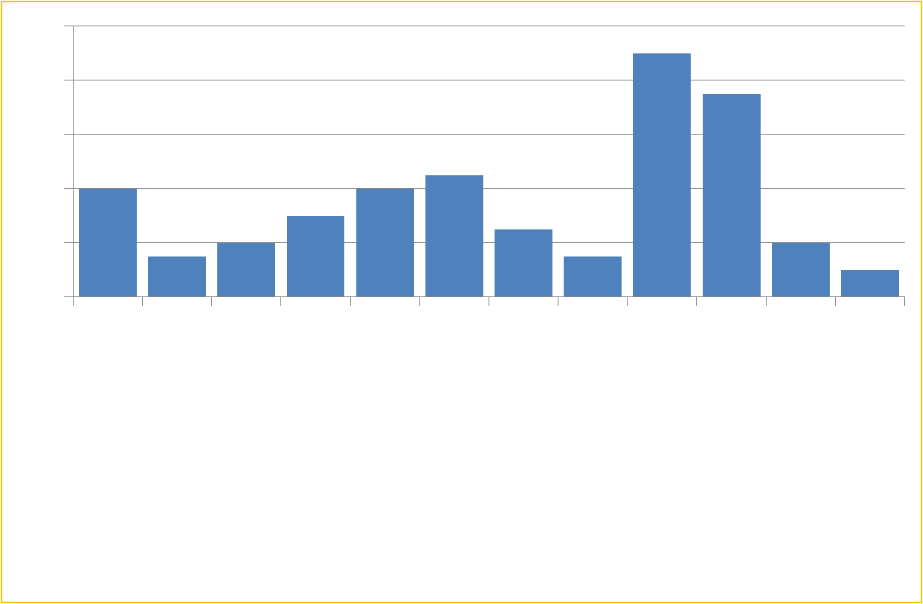

Period: 2007 to present; Area: Rajajinagar, Bangalore

MATERIALS AND METHODS

- Trees and shrubs survey conducted along transect routes.
- 2Km routes were selected with 15m belt on either-side
- All trees within the transect area identified
- Details on phenology
- Species were categorized based on their ecological value
  - Faunal dependence recorded
  - Aesthetic value
- Suitability of these trees for Urban situation evaluated

.

Results and Discussions:

Table 1. Trees for Highway planting – National & State

Species | Value | Visitors*
Shorea roxburghii | Nectar, Dust & Pollution Control | I,B
Butea monosperma | Nectar, Dust & Pollution Control | I,B,M
Syzigium cumini | Nectar, Fruits | I,B,M
Terminalia arjuna | Nectar | I
Pterocarpus marsupium | Nectar | I
Holoptelia integrifolia | Fruits, Dust & Pollution control | I,B
Albizia lebbeck | Dust & Pollution control | I
Tamarindus indica | Nectar, Fruits | I,B,M
Terminalia bellirica | Nectar | I,M
Givotia rottleriformis | Dust & Pollution Control | I,B
Gyrocarpus americanus | Dust & Pollution Control | I
Ailanthus excels | Dust & Pollution Control | I
Melia dubia | Nectar,Fruits, Dust & Pollution Control | IBM

* I – Insects, B – Birds, M - Mammals

Justification

- Pollution control
- Shade giving/air cooling
- Tall trees
- Good canopy spread
- Absorbtion of solar radiation / vehicular glare

Table 2. Trees for planting on narrow roads – 20 - 30 ft

Species | Value | Visitors*
Buchanania lanzan | Nectar,Fruits | I,B,M
Holarrhena antidysentrica | Nectar | I,B
Premna tomentosa | Nectar,Fruits | I,B
Bauhinia tomentosa | Nectar | I,B
Cochlospermum religiosum | Nectar | I,B
Gardenia latifolia | Nectar,Fruits | I,B,M
Gardenia gummifera | Nectar,Fruits | I,B,M
Lagerstroemia parviflora | Nectar | I,B
Memecylon umbellatum | Nectar,Fruits | I,B
Grewia spp. | Nectar,Fruits | I,B,M
Morinda pubescens | Nectar,Fruits | I,B,M
Tarenna asiatica | Nectar,Fruits | I,B,M
Cipadessa baccifera | Fruits | B,M
Breynia vitis-ideae | Fruits | B,M
Cordia myxa | Fruits | B,M
Erythrina suberosa | Nectar | I,B
Mundulea sericea | Nectar | I,B
Wrightia tinctoria | Nectar | I,B
Ixora pavetta | Nectar,Fruits | I,B,M
Dalbergia paniculata | Nectar | I,B
Capparis sepiaria | Nectar | I,B
Alangium salvifolium | Nectar,Fruits | I,B,M
Carissa carandas | Nectar,Fruits | I,B,M

Justification:

- Narrow bole
- Non buttressing
- Low height
- Aesthetically pleasing
- Non spreading canopies

Table 3. Trees for planting on medium width roads – 40 - 60 ft plus

Species | Value | Visitors*
Gmelina arborea | Nectar,Fruits | I,B,M
Albizia odoratissima | Nectar | I,B
Soymida febrifuga
Butea monosperma | Nectar | I,B
Vitex altissima | Nectar,Fruits | I,B,M
Vitex pubescens | Nectar,Fruits | I,B,M
Bridelia retusa | Fruits | B,M
Diospyros melanoxylon | Fruits | B,M
Canthium diccocum | Nectar,Fruits | I,B,M
Phoenix sylvestris | Nectar,Fruits | I,B,M
Anogeissus latifolia | Fruits | I
Ficus microcarpa | Fruits | I,B,M
Pongamia pinnata | Nectar | I,B
Terminalia chebula | Nectar,Fruits | I,B,M
Lagerstroemia microcarpa | Nectar | I,B
Madhuca indica | Nectar,Fruits | I,B,M
Terminalia paniculata | Nectar,Fruits | I,B
Chloroxylon swietenia | Nectar | I,B
Dolichandrone atrovirens | Nectar | I,B
Dolichandrone falcata | Nectar | I,B

Justification:

- Moderately tall
- Medium sized bole
- Medium sized canopy

Table 4. Trees for planting in Gardens and public parks

Species | Value | Visitors*
Gmelina arborea | Nectar,Fruits | I,B,M
Butea monosperma | Nectar | I,B,M
Buchanania lanzan | Nectar,Fruits | I,B,M
Vitex altissima | Nectar,Fruits | I,B,M
Vitex pubescens | Nectar,Fruits | I,B,M
Holarrhena antidysentrica | Nectar | I,B
Bridelia retusa | Fruits | B,M
Diospyros melanoxylon | Fruits | B,M
Ixora pavetta | Nectar,Fruits | I,B,M
Strychnos potatorum | Fruits | I,B
Syzigium cumini | Nectar,Fruits | I,B,M
Canthium diccocum | Nectar,Fruits | I,B,M
Phoenix sylvestris | Nectar,Fruits | I,B,M
Anogeissus latifolia |  | I
Premna tomentosa | Nectar,Fruits | I,B,M
Bauhinia tomentosa | Nectar | I,B
Terminalia arjuna | Nectar | I,B
Ficus microcarpa | Fruits | I,B,M
Cochlospermum religiosum | Nectar | I,B
Gardenia latifolia | Nectar,Fruits | I,B,M
Gardenia gummifera | Nectar,Fruits | I,B,M
Mitragyna parviflora(very imp. For Butterflies)
Justification:

- Aesthetically pleasing
- Shade giving
- Ornamental leaves and canopies
- Fragrant flowers
- Flowering for about 8 months a year in a phased manner.
- Support butterflies and bird

Table 6. Heritage, long living and trees for gunduthopus

What are heritage trees – Long living trees and biologically important.

Ficus benghalensis
Ficus mysorensis. Syn. Ficus drupaceae
Ficus religiosa
Ficus racemosa. Syn Ficus glomerata
Ficus amplissima. Bilibasri
Ficus tsjahela. Karibasri
Madhuca longifolia
Syzigium cumini. Naati or Naayinerle variety
Mangifera indica. Wild mango. Kulimaavu
Azadirachta indica

- Revive the concept of gunduthopus
- Ready germplasm of rare species
- Inculcate a love for nature amongst the people
- Provide a gathering space for local communities to celebrate festivals,fairs and marketing agriproduce(Santhe)

Table 7. Trees for general public

Buchanania lanzan | Tasty,fleshy fruits,edible seeds
Bridelia retusa | Tasty,fleshy fruits
Diospyros melanoxylon | Tasty,fleshy fruits
Syzigium cumini | Tasty,fleshy fruits
Phoenix sylvestris | Edible fruits
Gardenia gummifera | Tasty,fleshy fruits
Pongamia pinnata | Shade giving,air cooling
Madhuca indica | Tasty,fleshy fruits, oilseeds
Grewia spp. | Tasty,fleshy fruits
Acacia leucophloea | Bark used to distill liquor
Albizia amara | Leaves used as shampoo
Hardwickia binate | Rope and timber and charcoal
Acacia conchinnia | Fruits for Shampoo
Limonia acidissima | Edible fruits
Holoptelia integrifolia | Edible seeds
Tamarindus indica | Fruits sold commercially
Phyllanthus emblica | Edible fruits
Ziziphus mauritiana | Edible fruits
Butea monosperma-. | leaves for plates
Cordia myxa | Edible fruits
Madhuca longifolia | Edible fruits, oilseeds
Catunaregam spinosa / Randia spinosa- | Fruits Used as soap
Ailanthus excels | Timber value
Melia dubia | Timber value
Sapindus emarginatus | Fruits used as shampoo

Table 8. Bee flora for Gardens and woodlots

Species | Flower Size | Nectar Availability
Gmelina arborea | M | M
Shorea roxburghii | S | M
Butea monosperma | M | M
Buchanania lanzan | S | M
Holarrhena antidysentrica | S | M
Ixora pavetta | S | M
Cochlospermum religiosum | LA | LO
Gardenia latifolia | LA | LO
Gardenia gummifera | M | LO
Pterocarpus marsupium | S | M
Lagerstroemia parviflora | S | LO
Lagerstroemia microcarpa | S | LO
Madhuca indica | S | LO
Grewia spp. | M | H
Chloroxylon swietenia | S | M
Dolichandrone atrovirens | S | H
Dolichandrone falcata | M | M

* LO – Low, M – Medium, S – Small, H - High

Table 9. Trees with hollows for cavity nesting birds

Species | Age of trees (years) | Cavity nesters recorded
Ficus benghalensis | >30 | Spotted owlet, Mynas, Parakeet, Roller
Ficus mysorensis | >40 | Spotted owlet, Mynas, Parakeet, Roller
Ficus religiosa | >30 | Spotted owlet, Mynas, Parakeet,
Syzigium cumini | >40 | Mynas, Parakeet,
Ficus racemosa | >25 | Mynas, Parakeet,
Bombax ceiba | >20 | Spotted owlet, Mynas, Parakeet,
Pterocarpus marsupium | >35 | Spotted owlet, Mynas, Parakeet,
Madhuca longifolia | >40 | Spotted owlet, Mynas, Parakeet,
Mangifera indica | >40 | Spotted owlet, Mynas, Parakeet,
Albizia lebbeck | >25 | Mynas, Parakeet
Albizia odoratissima | >25 | Mynas, Parakeet

Table 10. Trees that sustain nectar feeders

Species | Flower type | Nectar quantity
Gmelina arborea | M | M
Albizia odoratissima | S | LO
Butea monosperma | M | M
Vitex altissima | S | LO
Vitex pubescens | S | LO
Holarrhena antidysentrica | S | M
Ixora pavetta | S | M
Syzigium cumini | S | M
Pongamia pinnata | S | M
Pterocarpus marsupium | S | M
Buchanania lanzan | S | LO
Careya arborea | M | M
Lagerstroemia parviflora | S | LO
Lagerstroemia microcarpa | S | LO
Madhuca indica | M | H
Memecylon umbellatum | S | LO
Grewia spp. | S | M
Chloroxylon swietenia | S | M
Dolichandrone atrovirens | M | H
Dolichandrone falcate | M | H
Acacia leucophloea | S | LO
Albizia amara | S | LO
Morinda pubescens | S | LO
Cassia fistula | S | LO

Table 11.

Trees for Lake shore planting

Species | Value | Purpose
Strychnos potatorum | Purifies water | Along margins
Syzigium cumini | Fruits for birds | Island planting
Terminalia arjuna |  | Foreshore planting
Pongamia pinnata | Flowers for insects | Island planting for heronries
Dendrocalamus strictus | Hide for birds | Island planting for heronries
Mitragyna parviflora | Butterfly attracting flowers | Island planting for heronries
Ficus racemosa | Fruits for birds | Along margins
Breynia vitis-ideae | Fruits for birds | Along margins
Acacia planifrons | Flat-topped canopy | Island planting for heronries
Barringtonia acutangula | Withstands submergence | Foreshore planting

Table 12. Trees that have never been planted in cities

Albizia odoratissima | Pterocarpus marsupium | Tarenna asiatica
Shorea roxburghii | Terminalia chebula | Mitragyna parviflora
Butea monosperma | Buchanania lanzan | Cassine glauca
Buchanania lanzan | Careya arborea | Diospyros melanoxylon
Vitex altissima | Lagerstroemia parviflora | Ziziphus mauritiana
Vitex pubescens | Lagerstroemia microcarpa | Cipadessa baccifera
Holarrhena antidysentrica | Madhuca indica | Terminalia bellirica
Bridelia retusa | Memecylon umbellatum | Givotia rottleriformis
Diospyros melanoxylon | Grewia spp. | Breynia vitis-ideae
Ixora pavetta | Terminalia paniculata | Cordia myxa
Strychnos potatorum | Chloroxylon swietenia | Erythrina suberosa
Canthium diccocum | Dolichandrone atrovirens | Mundulea sericea
Maytenus senegalensis | Acacia leucophloea | Wrightia tinctoria
Anogeissus latifolia | Albizia amara | Catunaregam spinosa / Randia spinosa.
Premna tomentosa | Sterculia urens | Ixora pavetta
Bauhinia tomentosa | Morinda pubescens | Dalbergia paniculata
Cochlospermum religiosum | Hardwickia binata | Gyrocarpus americanus
Gardenia latifolia | Acacia conchinnia | Acacia planifrons
Gardenia gummifera | Vitex altissima | Capparis sepiaria
Alangium salvifolium

Urban Plantations – Current Scenario in Bangalore

Of late it has been observed that the focus is on planting only a few species in and around Bangalore, that too, most of these species are exotics like Tabebuia rosea, Mahogany,Markhamia etc Most of them are ornamental or with timber value.
These species hardly have any value in terms of supporting bio diversity and are not ideally suited for our Latitude,Altitude, Soil,Temperature,Rainfall,Moisture levels,Sunlight etc
The long term effects of planting such trees also needs to be studied.
These trees are also being planted in all available spaces giving an opportunity for these species to dominate the landscape, at the cost of endemic trees and other flora.
Species selection for raising saplings in forest nurseries are not planned and all seeds are generally collected from a single tree rendering a poor genetic makeup.Rules for scientific seeds collection are not followed, which may render these trees vulnerable to epidemic diseases.

References
Forest Trees of South India – Neginhal S.G
Golden Trees,Greenspaces and Urban Forestry – Neginhal.S.G
Research papers – Dr S.Subramanya.

Acknowledgements
ATREE,Bangalore.
Karnataka Forest Department.
Tamilnadu Forest Department.
Dr. S. Subramanya, GKVK
Sheshadri Ramaswamy.

